NAME: Ayesha shahzadi
SAP ID: 72858
LAB TASK: 09
TASK 01
- Expression: A + B * C
# | Operation | Token | Stack (bottom → top) | Postfix
1 | Add to output | A | Empty | A
2 | Push + | + | + | A
3 | Add to Output | B | + | AB
4 | Push* | * | +,* | AB
5 | Add to output | C | +,* | ABC
6 | Pop*and+ | End | Empty | ABC*+

Expression 02: (A - B) * C
# | Operation | Token | Stack (bottom → top) | Postfix
1 | Push | ( | ( | Empty
2 | Add to output | A | ( | A
3 | Push | - | (, - | A
4 | Add to output | B | (, - | AB
5 | Pop | ) | Empty | AB-
6 | Push | * | * | AB-
7 | Add to output | C | * | AB-C
8 | Pop | End | Empty | AB-C*

Expression 03 A / B + C / D
# | Operation | Token | Stack (bottom → top) | Postfix
1 | Add to output | A | Empty | A
2 | Push/ | / | / | A
3 | Add to output | B | / | AB
4 | Pop/and Push* | + | + | AB/
5 | Add to output | C | + | AB/C
6 | Push/ | / | +, / | AB/C
7 | Add to output | D | +, / | AB/CD
8 | Pop/ | End | Empty | AB/CD/+

Task 2: Dry Run
Expression: (A + B) * C
# | Operation | Token | Stack (bottom → top) | Postfix
1 | Push | ( | ( | Empty
2 | Add to output | A | ( | A
3 | Push | + | ( , + | A
4 | Add to output | B | ( , + | AB
5 | Pop | ) | Empty | AB+
6 | Push | * | * | AB+
7 | Add to output | C | * | AB+C
8 | Pop | End | Empty | AB/+C*
TASK 3
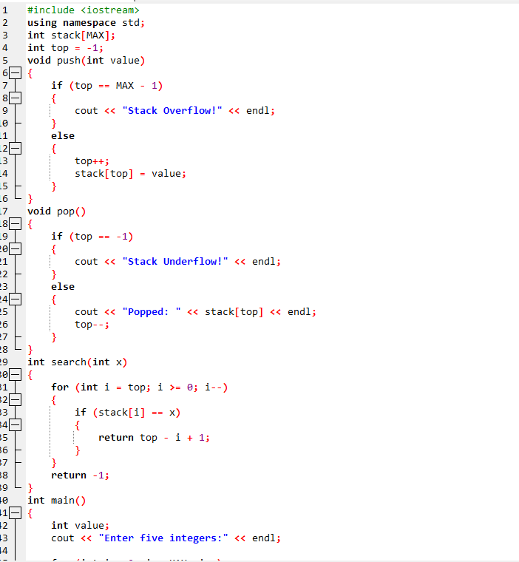
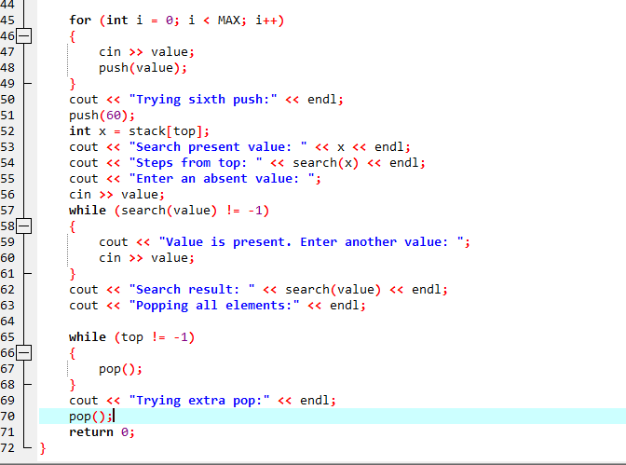
OUTPUT:


